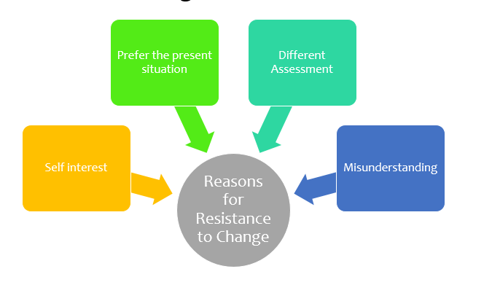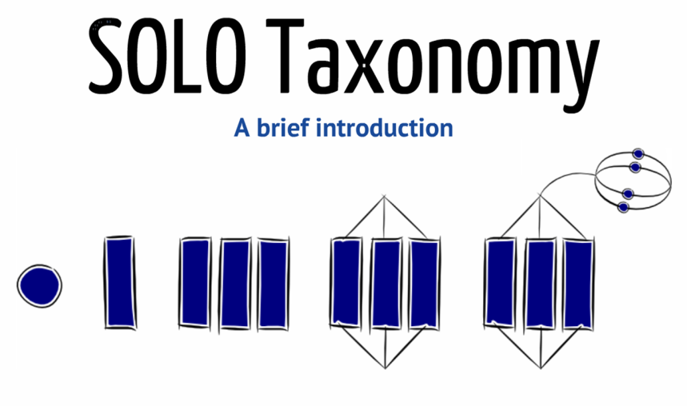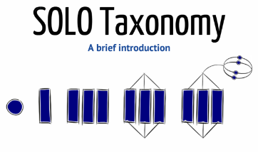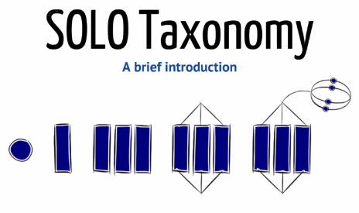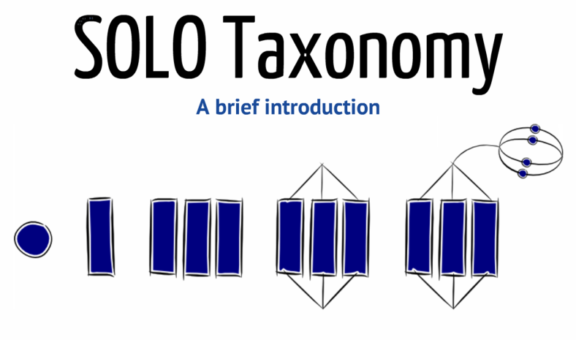

**Managing Change**

Explain Kotter and Schlesinger’s two models and clarify what they mean by each factor and how this could affect change or help overcome change.

How could change be valuable to a business?

**Unistructural**

**Extended Abstract**

**Relational**

**Multistructural**

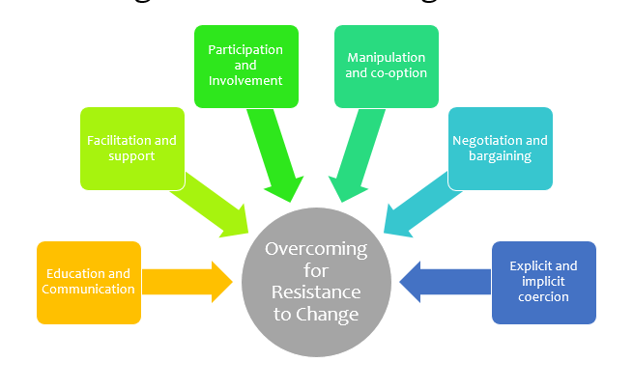

Explain the three key areas when assessing the value of change

Examine what each key area means and illustrate how this works in the business world with an example